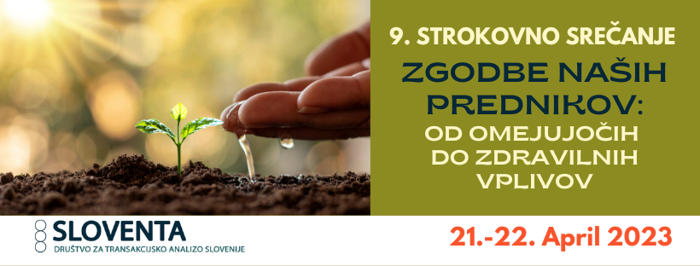ONLINE PROGRAM
FRIDAY, 21. 4. 2023
16:30 – 18:00 Plenary lecture:
Dr. Gloria Noriega Gayol (TSTA-P), Untangling and Healing the Family Tree

Unconsciously, we may be repeating in our current relationships the positive scripts of our ancestors, as well as their unresolved conflicts, even without having known them! The positives may be linked to topics such as: love, empathy, caring and awareness. The negatives to topics such as: illegitimacy, addictions, violence, infidelity and more, covered by family secrets running through several generations. We are the owners of the links that may be opened to recognize both of these through our Adult Ego State, for our benefit and the benefit of our descendants.

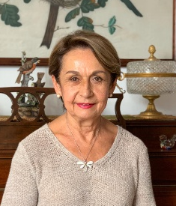
Dr. Gloria Noriega Gayol, PhD, is the proud mother of two adult children and grandmother of three lovely grandsons. She is the President and Director of the Mexican Institute of Transactional Analysis (IMAT) in Mexico City and a former President of the International Transactional Analysis Association (ITAA). In 2008 she received from the ITAA the Eric Berne Memorial Award, for her research on "Mechanisms of Script Transmission", as a contribution to the development of the transactional analysis theory. Gloria can be reached at email: gnoriega@imat.com.mx and website: http://www.imat.com.mx

SATURDAY, 22. 4. 2023

11:00 – 12:30 Delavnica:

Evelyne Papaux (TSTA-E), An Educational Perspective on transgenerational and cultural scripts

Understanding transgenerational and cultural scripting processes invites us to develop more awareness about how we cope with such issues in our everyday relationships. And as practitioners it raises questions such as how to empower ourself and our clients in dealing with the uncertainty of expanding our frame of reference and challenging some of our beliefs in order to learn, grow and be part of social groups. This lecture will invite participants to explore how TA concepts can offer us a useful and powerful perspective when we see and use their interconnectedness rather than considering them as different tools. As an example we will more specifically inquire into the combination of the concepts of frame of reference and the 5Ps (J.I.Clarke) and see in what way this can expand our perceptions and enhance a reflective practice.
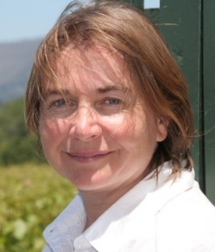
Evelyne Papaux is a TSTA-E. For years she has been working with babies, children and their families; children with special needs, children in day care centres and in homecare. She is now active in the initial and ongoing training for educators for young children. She sees TA as a significant means of promoting prevention and /or resilience and empowering people.

